TopCoder Copilot Profiles Front End Assembly Deployment Guide

Revision History
Author | Revision Number | Date
TCSDEVELOPER | 1.0 | 08/28/2010

Deployment Instructions 3
1. Organization of Submission 3
2. Application Setup 4
3. Database Setup 5
4. Deployment Instructions 5
5. Starting 5
6. Verification 6
7. Resource Contact List 8

Deployment Instructions

Organization of Submission

The submission has following directory structure:

docs

Contains this document which is the Deployment Guide for the TopCoder Copilot Profiles Front End assembly.

resources

Contains the configration file for TopCoder Website application with some configuration parameters added, used to initialize Constants.java class (in TC.properties).

Contains a updated web.xml for TC site which has spring integrated into the web application.

Contains a newly added applicationContext.xml which is used by spring to load service creation configuration, the CopilotProfileService and CopilotProjectService implementation is configured in this file.

db_scripts

Contains there kinds of SQL scripts
- DDL scripts : the scripts setup the database with schema required for copilots
- Query scripts: contains the new queries which should be added via Topcoder Query Tool
- Test Data scritps: contains the test data which can be used to test this assembly.

See database setup section for details.

static

Contains the static resources (CSS, Javascritps and Images) that are newly introduced in this assembly. They should be copied to the apache HTTP service during the deployment, see the following section for details

src

main

Contains the updated and newly added sources for classes and views during this assembly.

test_files

Contains the test_files which are needed to test this assembly.

It contains an image directory which should be copied to the Apache service to test the header image rendering of the copilots.

copilot pool and profiles services

This directory provides a component structure for the two implementations of
CopilotProvideService and one mock implementation of CopilotProjectService, it contains the ant scripts to compile and package it as a component named copilot_pool_and_profile_services.jar. So that it can be deployed to the service and used like a topcoder component.

build_tc.xml

The update ant script for buidling and deploying TC websites.

Application Setup

The TopCoder Copilot Profiles Front End Assembly is expected to be integrated into existing TopCoder Website application.

New static fields were added to Constants class, and thus new configuration parameters have been added to TC.properties file.

The web.xml for the TC web site has been changed during the assembly, the following fragment has been added to have the spring integrated into the TC website.

<context-param>
<param-name>contextConfigLocation</param-name>
<param-value>WEB-INF/applicationContext.xml</param-value>
</context-param>

<listener>
<listener-class>org.springframework.web.context.ContextLoaderListener</listener-class>
</listener>

A new file applicationContext.xml has been added, which is the spring configuration file for loading CopilotProfileService and CopilotProjectService instances. After deploying, it should under the directory WEB-INF, the same as web.xml.

Database Setup

To update the existing databases to reflect the changes introduced with this assembly do the following:

- In the database tcs_catalog, run the script 1_copilot_pool_ddl.sql to create new schema.
- In the database tcs_catalog, run the script 2_copilot_profile_type_setup.sql to insert the look up values for copilot profile types.

You need to insert test data (contains new users, new coders, copilot pool data, coder ratings, and user images information) to fully test this assembly

- To insert the test data, you need to run the script 3_copilot_pool_test_data.sql to insert them all.

There are two queries copilot_pool_images_QUERY and copilot_pool_members_QUERY introduced during Copilot Pool Front end assembly. You’d better add them into the query tool also to make the whole application consistent.

There is one new query introduction in this assembly called copilot_user_info_QUERY

- To access the TopCoder Query Tool, make sure your VM is running and configure correctly and access http://tc.cloud.topcoder.com to login first (usr:heffan / pwd : password).
- After login, you can access http://tc.cloud.topcoder.com/query/query to create the new queries:
  - The 3 queries are all put under db_scripts/query directory
  - You should select TCS Catalog in the DB selection of query tool
  - Click new command to create a new command called copilot_pool_members, select the group Util, then save.
  - Click New Query to create two new queries, the contents of the queries are in the SQL files mentioned before:
Query name | SQL file name | Description
copilot_pool_members | db_scripts\query\copilot_pool_members_QUERY.sql | This query will be used by the SqlCopilotProfileService to get the copilot pool members
copilot_pool_images | db_scripts\query\ copilot_pool_images_QUERY.sql | This query will be used by the ViewCopilotPool request processors to retrieve copilot image paths from the persistence
  - Click new command to create a new command called copilot_profile, select the group Util, then save.
  - Click New Query to create one query, it’s important to note that this query needs one input parameter. So after saving the query, click [edit query input], select the uid from list and click add to add the input into the query.
Query name | SQL file name | Description
copilot_user_info | db_scripts\query\copilot_user_info_QUERY.sql | This query will be used by the request processors to get the copilot user information like handle, user id and image path

Deployment Instructions

This section provides the instructions for integrating this assembly within the environment provided on Cloud VM instances.

- Unpackage the submission archive to some temporary directory.
- Copy css, images, and js sub-directories from static directory to /usr/local/apache/tcdocs directory.
- Copy images sub-directories from test_files directory to /usr/local/apache/tcdocs directory. It contains the user images for testing purpose.
- Copy lib, resources, src directories and build_tc.xml file to /home/tc/web directory.

Then you need to build and deploy tc app and distui app in order

First you need to run ant -f build_distui.xml clean under the login distui in /home/distui/web

Then to deploy tc app, login into the VM with username tc

- Use command killall java to shutdown the Jboss first
- Then run ant –f build_tc.xml deploy under the directory /home/tc/web to deploy the tc
- Then use jbb to go to the JBoss bin directory, and use ./start.sh to start the Jboss

Finally to deploy distui app, login into the VM with username distui

- Use command killall java to shutdown the Jboss first
- Then run ant –f build_distui.xml deploy under the directory /home/distui/web to deploy the distui
- Then use jbb to go to the JBoss bin directory, and use ./start.sh to start the Jboss

Starting

- Deploy the TopCoder Website (tc) and TopCoder UI (distui) I application
- Start JBoss server instance as described in section 4 (consult the VM Member Instructions document available at http://www.topcoder.com/wiki/display/docs/VM+Image+2.1.5)
- Note that after running the SQL script to insert test data or after adding new queries into the TopCoder query tool, you may need to refresh the cache be restarting cache JBoss server instance.

Verification

Note on the mock service, the mock profile service will always return a copilot’s profile that has user id 10001 and copilot profile id 1.

The mock project service will always return a copilot project for the ViewCopilotProject request processor, the copilot project has id 1 and belong to copilot profile id 1.

To verify the deployment, first you need to go to the http://tc.cloud.topcoder.com/tc , the home page should be displayed correctly. And click the Copilot Opportunities, you will see the new added Copilot Pool link.

To access the copilot profile page, you need to enter the url http://tc.cloud.topcoder.com/tc?module=ViewCopilotProfile&pid=1

pid = 1 means view the copilot profile with copilot profile id 1

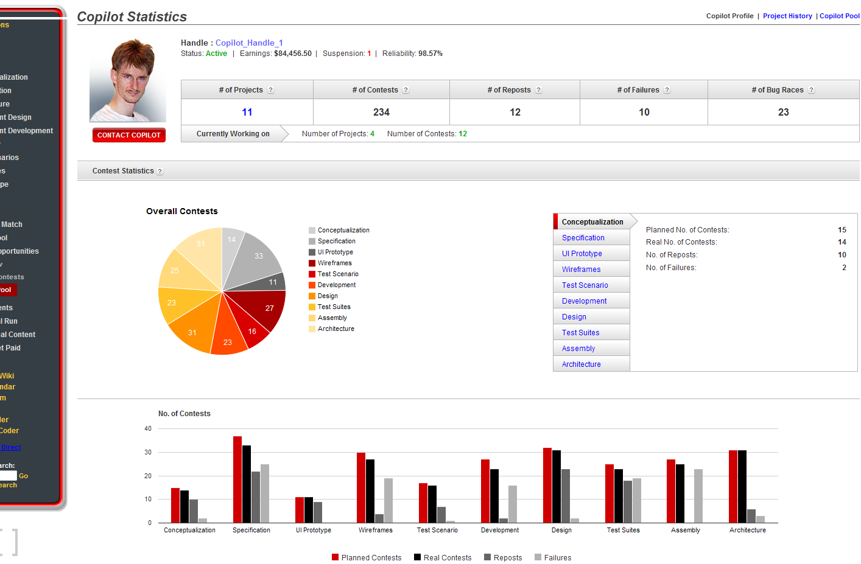

You will see the copilot profile page is display, hover your mouse on the charts to see pop up tips.

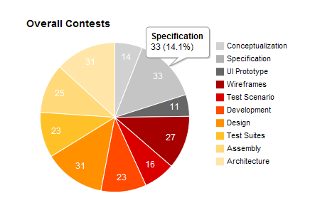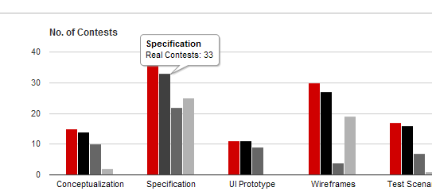

Check the member contact and handle’s link.
Check the right statistic panel, click on different contest types to view:
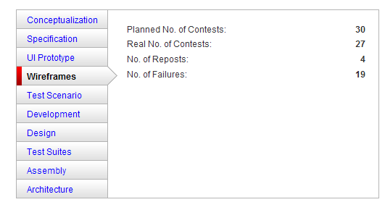

Check the tips of each statistics

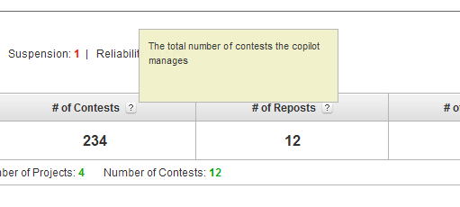

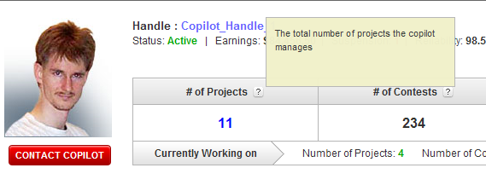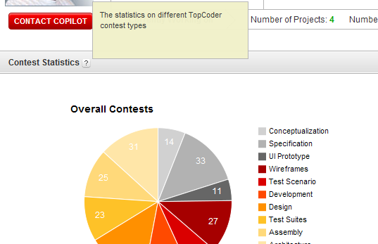

Click on the blue number link under the header # of Projects, you will step into the copilot project history page, the link is http://tc.cloud.topcoder.com/tc?module=ViewCopilotProjectHistory&pid=1

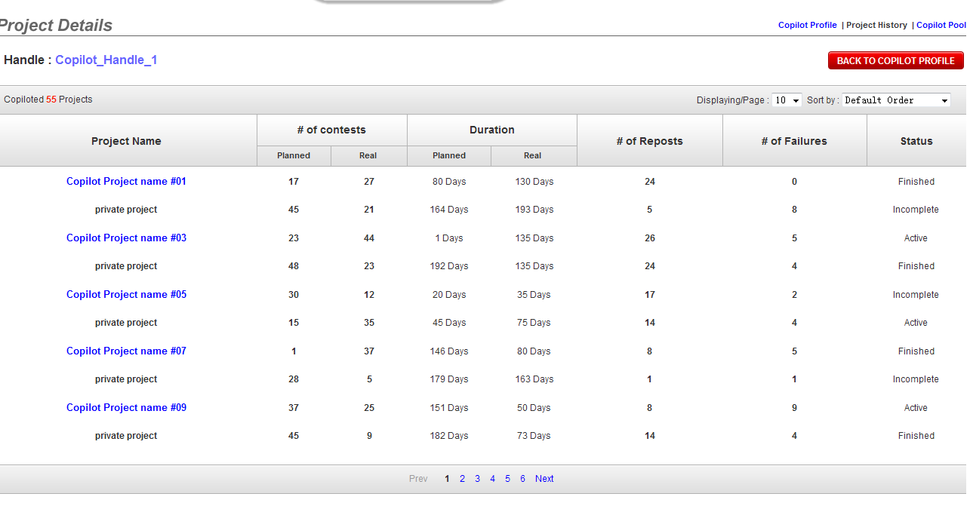

You can see that the copilot projects which are private are displayed as private project without project details link.

Click on each header to sort the table.

Use the drop down control to change the paging size and sorting method.

Click a project name link to view copilot project details

Check the right statistic panel, click on different contest types to view:

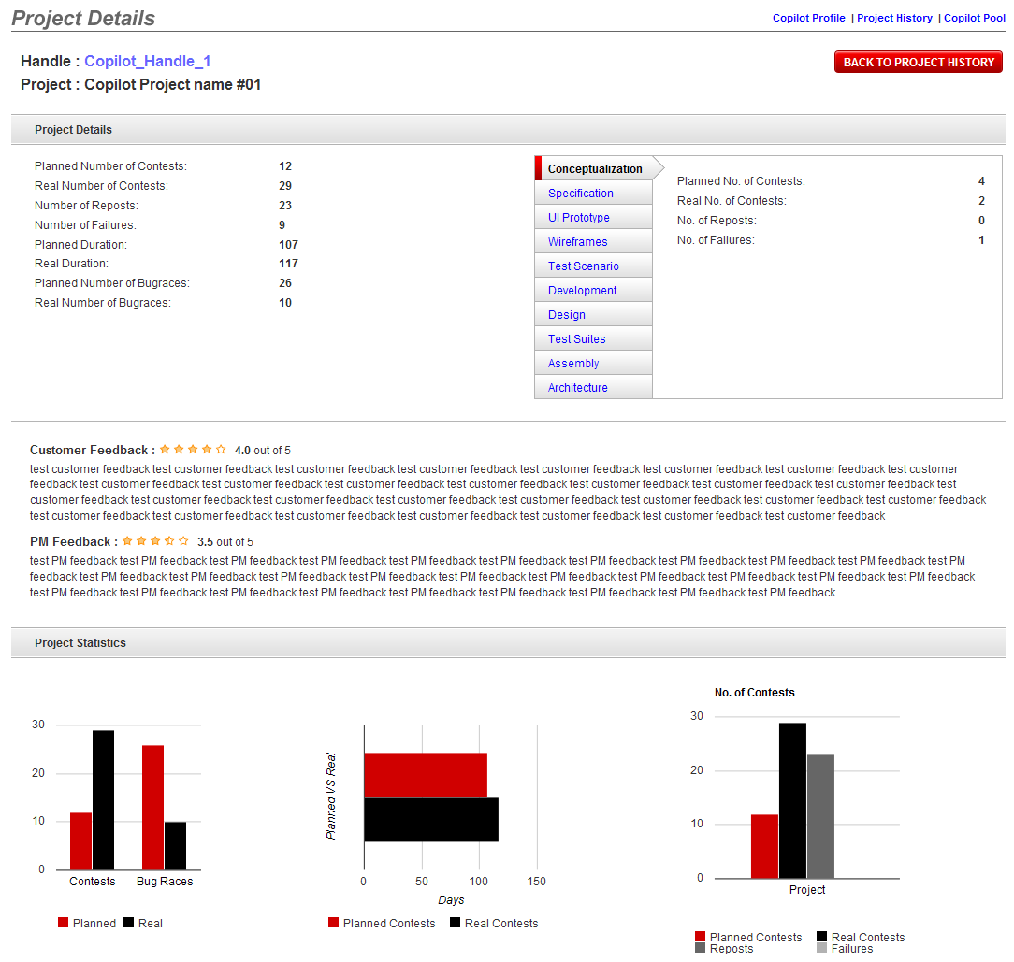

The rating stars are rendered base on the ratings. Move your mouse on chart bars to see popup tips:

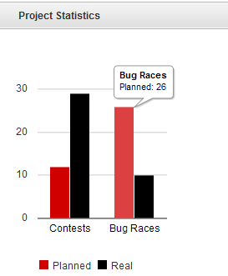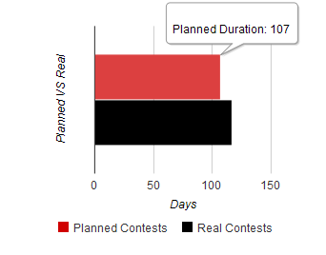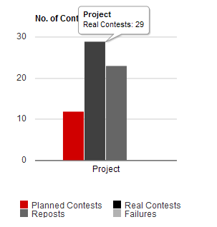
Check the right statistic panel, click on different contest types to view:

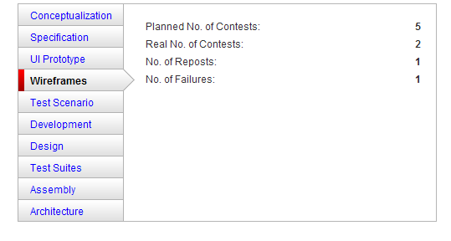\
Check the handle link, and the other links like copilot pool, project history, copilot profile.

Resource Contact List

Name | Resource Email
TCSDEVELOPER

